African American History Month February 2010
African American History Month, also called Black History Month, has been observed since the nation's bicentennial in 1976 as a way to recall and commemorate the achievements and history of Americans of African descent. Its origins are found in what was originally known as Negro History Week, established in the 1920s through the efforts of Dr. Carter G. Woodson and other African American scholars and observed during the second week of February to coincide with the birthdays of Frederick Douglass and Abraham Lincoln. Presented here are BLS data that provide an economic snapshot of African Americans in the United States today.


African Americans in the Labor Force
In 2009, there were 17.6 million African Americans in the labor force — accounting for 11 percent of all Americans aged 16 years and older who were employed or looking for work. The African American labor force is younger than the total labor force; 63 percent of African American labor force participants are under the age of 45, compared with 58 percent of all labor force participants.
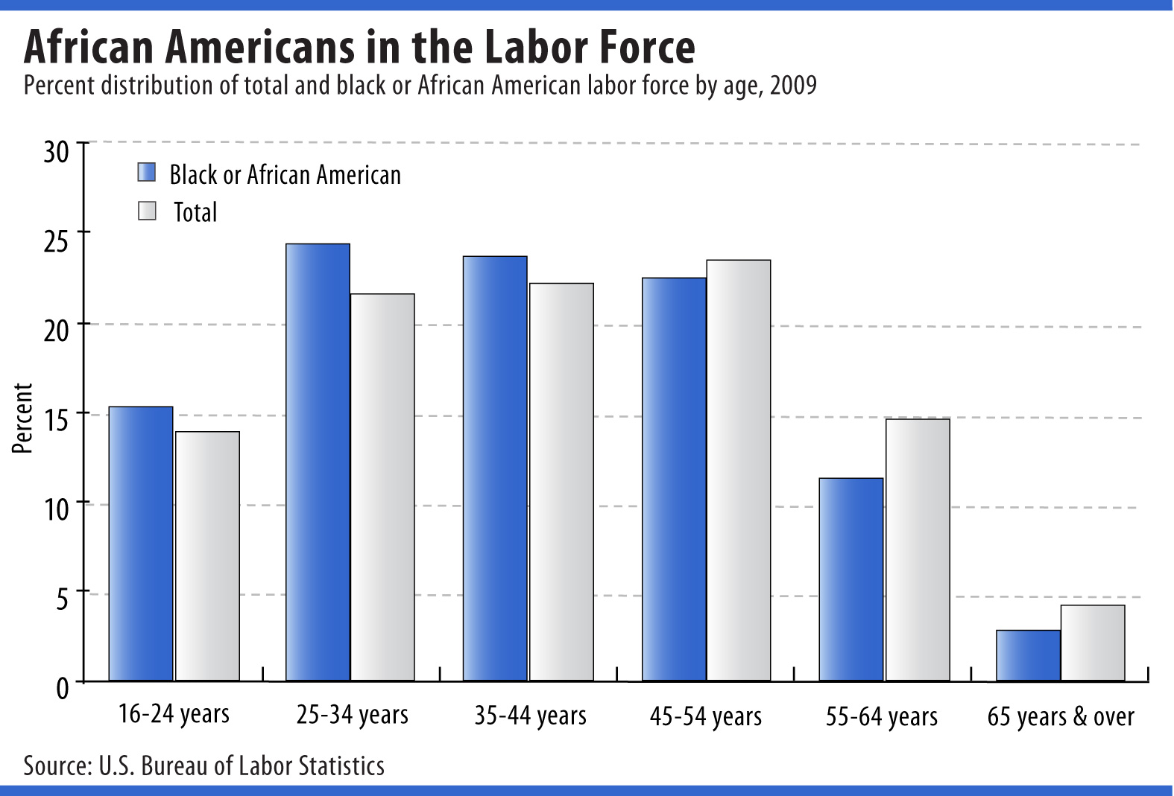
Source: Current Population Survey

Employment by Industry
Of those African Americans in the labor force, about 15 million were employed in 2009. More worked in the education and health services sector than in any other industry sector. In 2009, there were about 4.5 million African Americans — 30 percent of employed African Americans — working in education and health services. Among all employed persons in the United States, 23 percent were employed in education and health services.
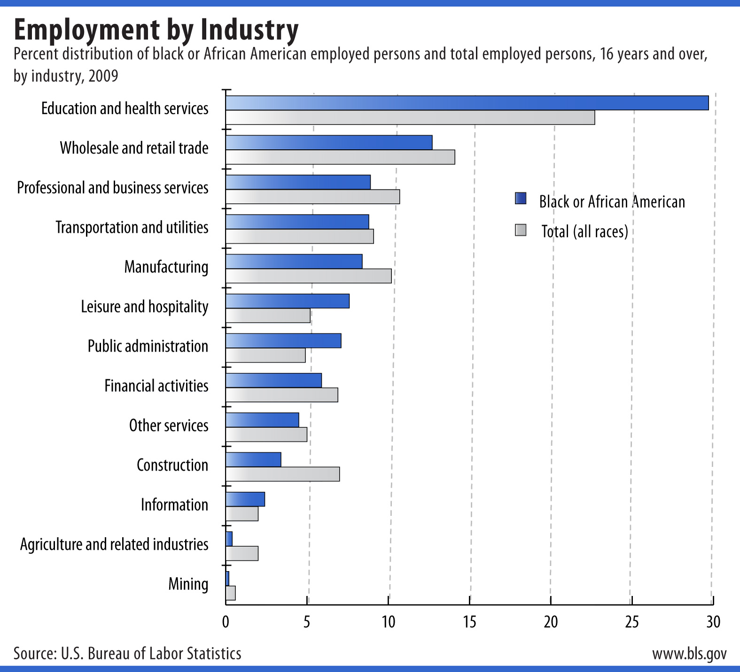

Source: Current Population Survey

Unemployment rate

Since 1972, the unemployment rate for African Americans age 16 years and over has been higher than that of the total labor force. However, the difference between the jobless rates for African Americans and the total labor force has narrowed—from a peak difference of 9.9 percentage points in 1983 to a difference of 5.5 percentage points in 2009.

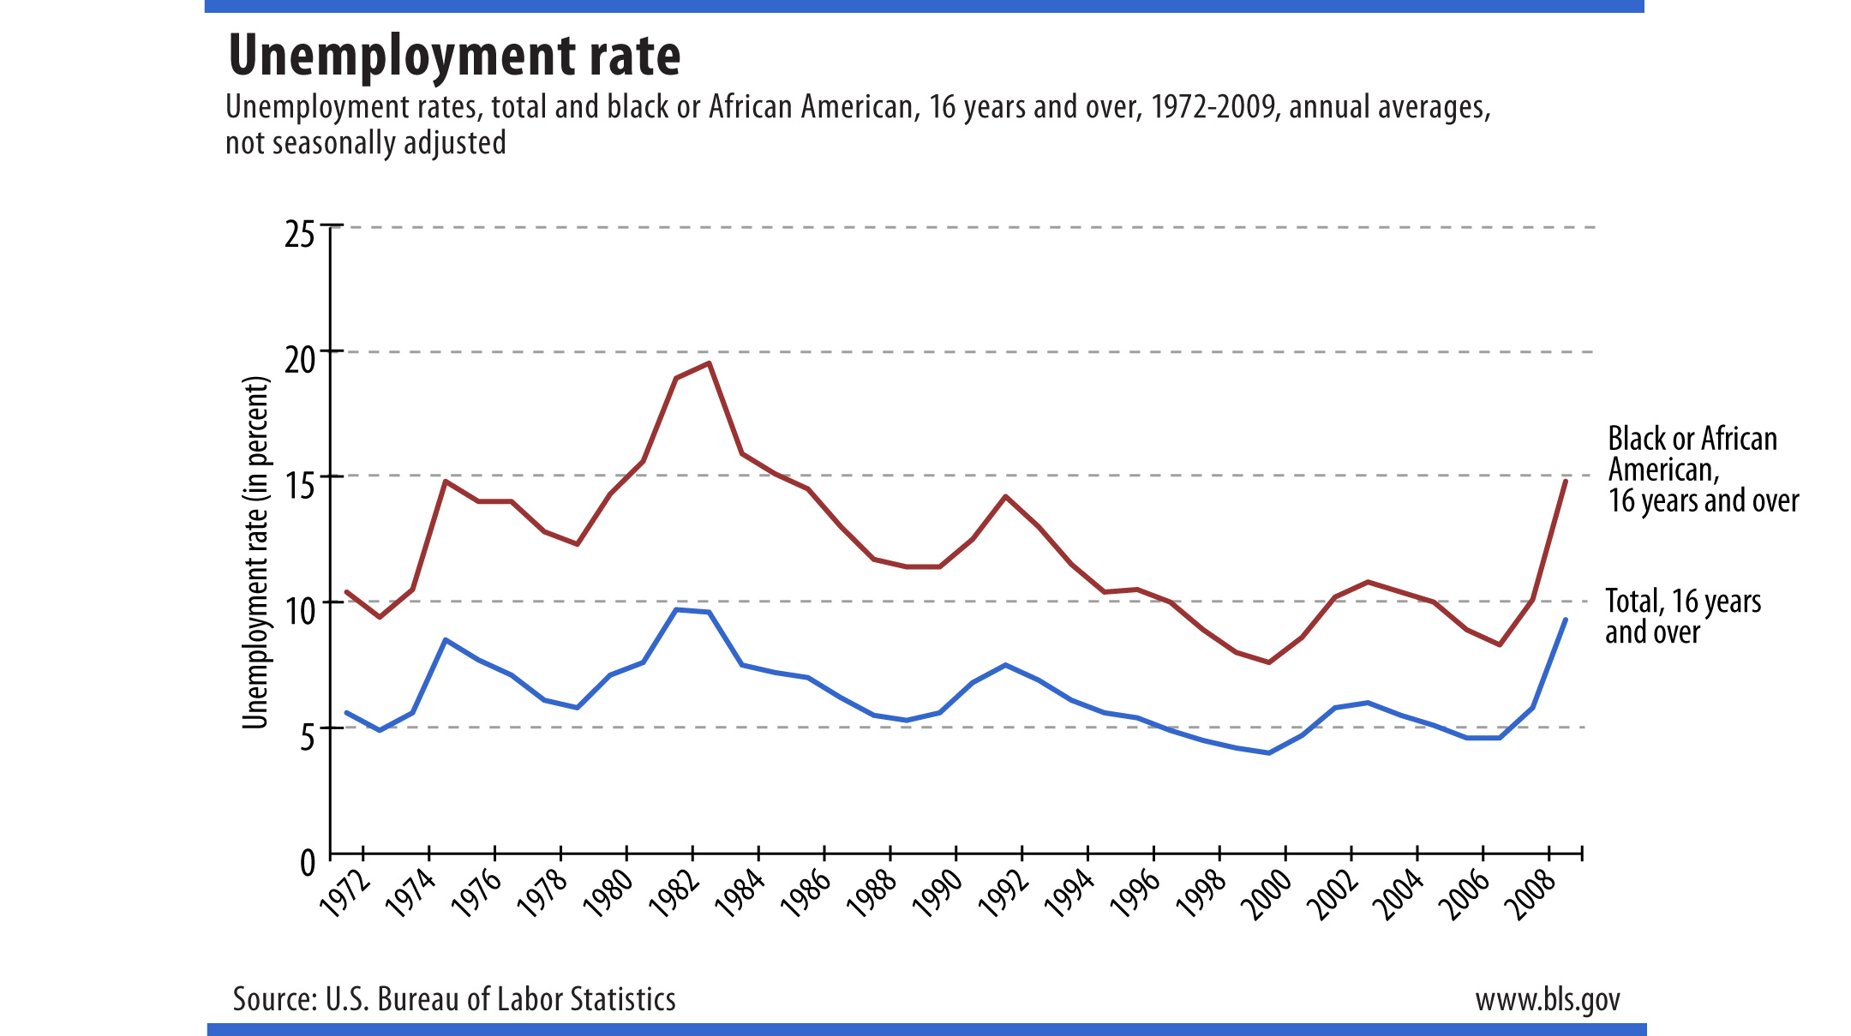

Source: Current Population Survey

Educational Attainment
In 1992, eighteen percent of the African Americans in the labor force had not graduated from high school. By 2009, that figure had declined by one-half to 9 percent. Of note, African Americans in the labor force that had graduate from college increased from 16 percent in 1992 to 24 percent in 2009.
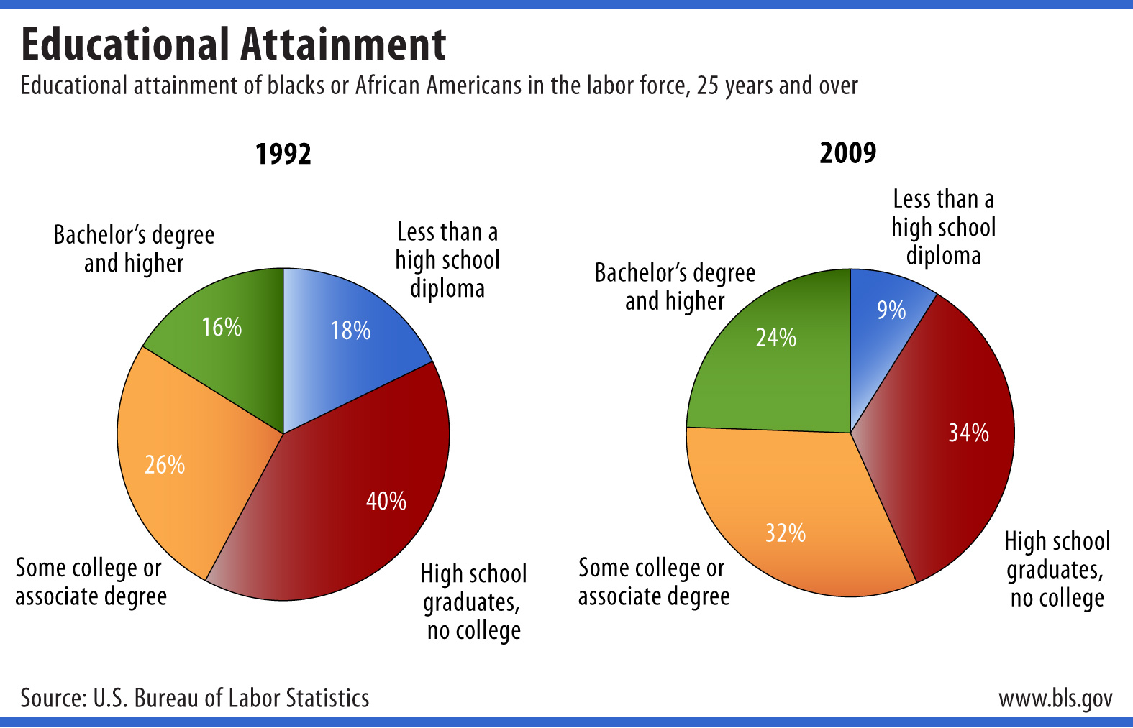
Source: Current Population Survey

More School, More Earnings
Higher education leads to higher earnings. African Americans graduating with a bachelor’s degree and higher degree earn more than twice as much as those with less than a high school diploma.
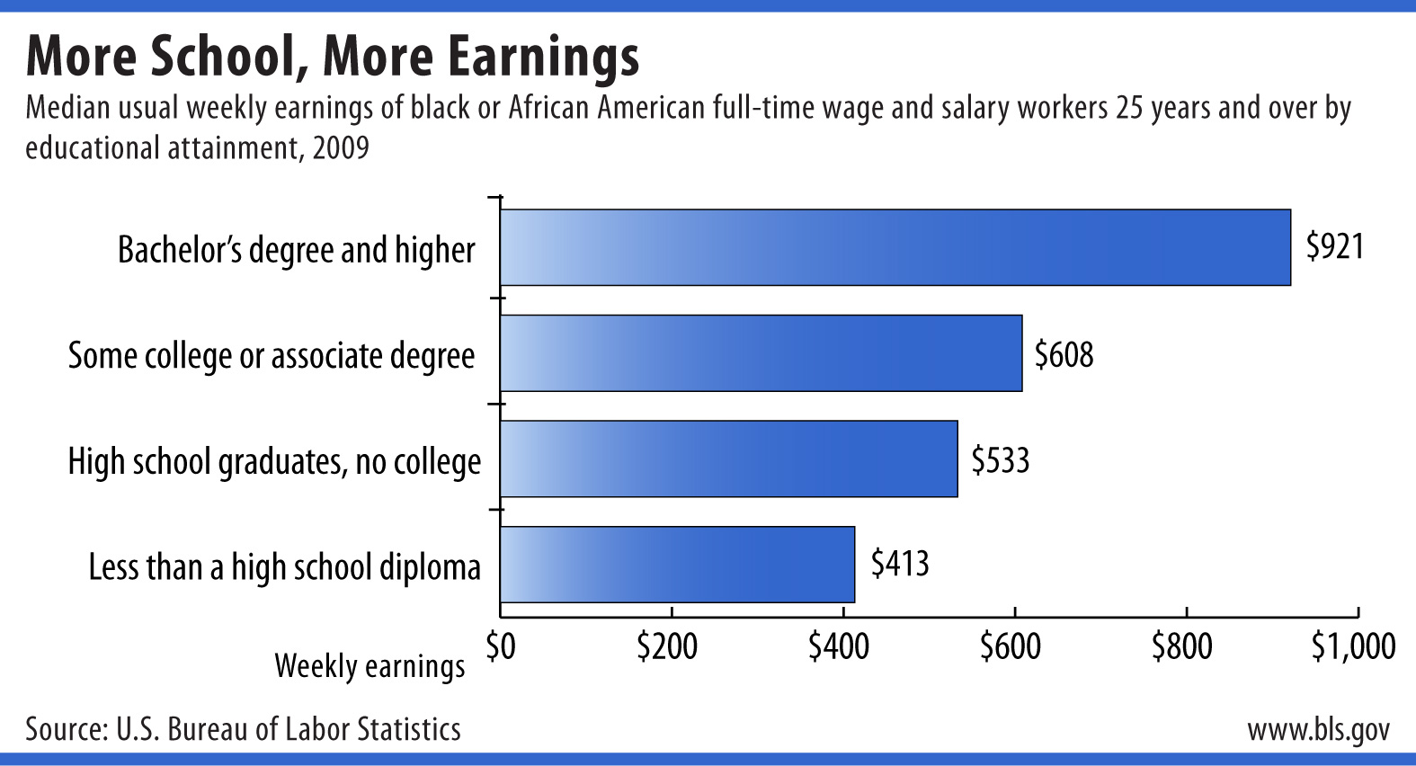
Source: Current Population Survey

Additional Education, Less Unemployment
Unemployment rates fall as educational attainment increases as well. In 2009, the unemployment rate for African Americans 25 years and over without a high school diploma was over 21 percent, while the jobless rates for high school graduates and those graduating with a bachelor’s degree and higher were 14.0 and 7.3, respectively.
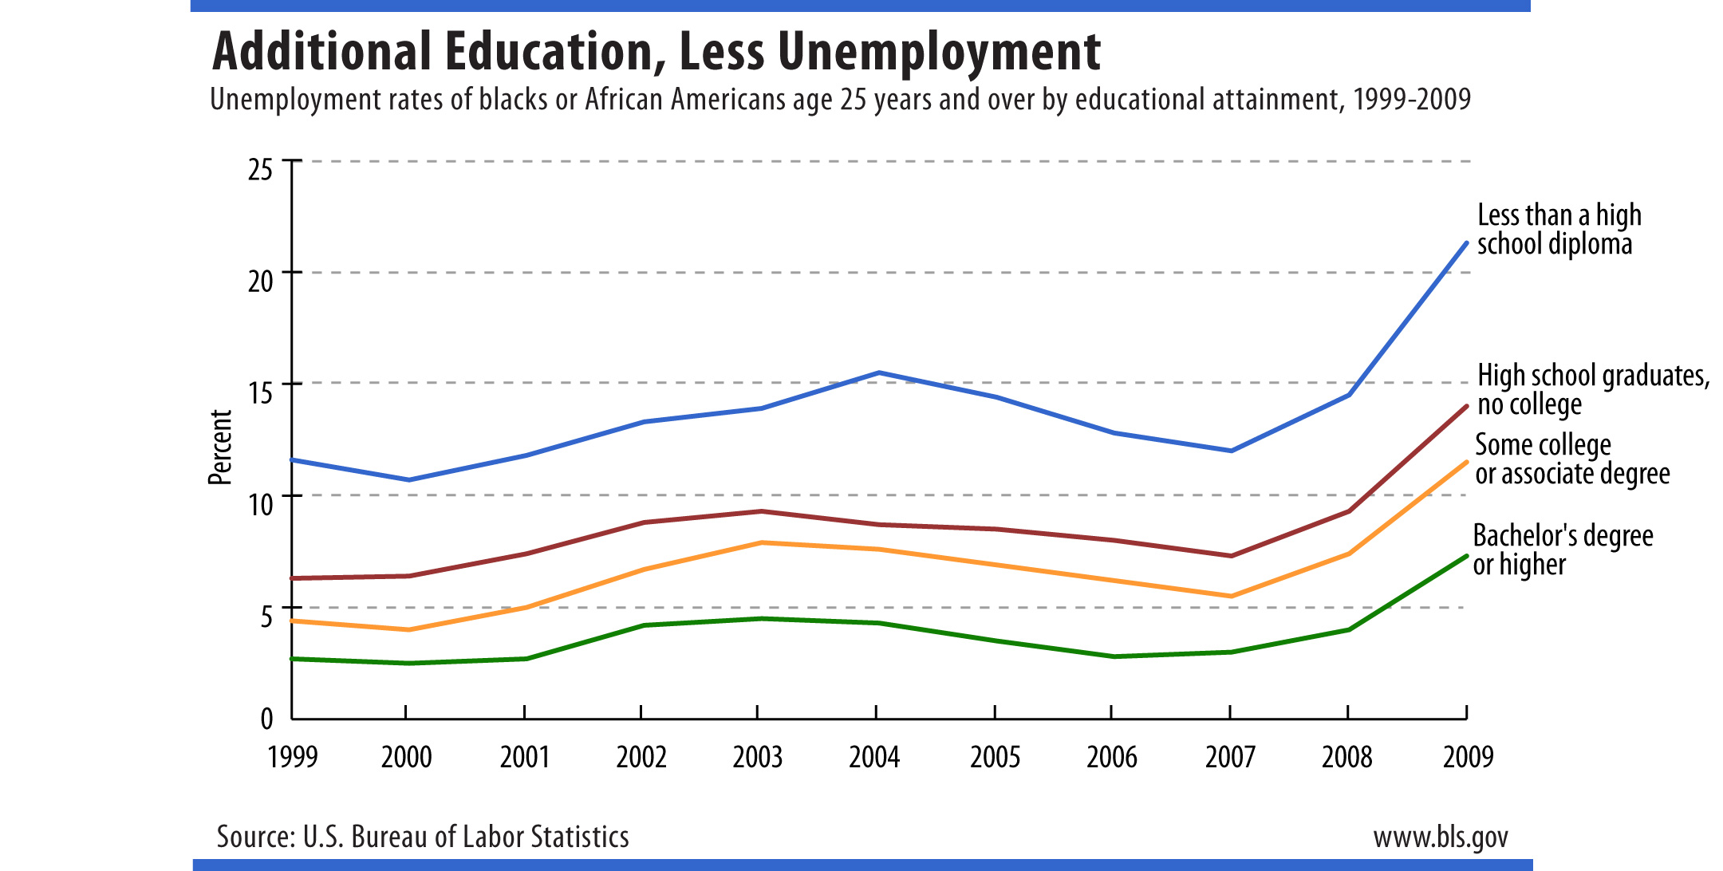
Source: Current Population Survey

Time Use
There is more to life than work; the American Time Use Survey measures the amount of time devoted each day to various activities. The chart below shows how employed African Americans and employed persons in the total U.S. population spend time on an average workday.
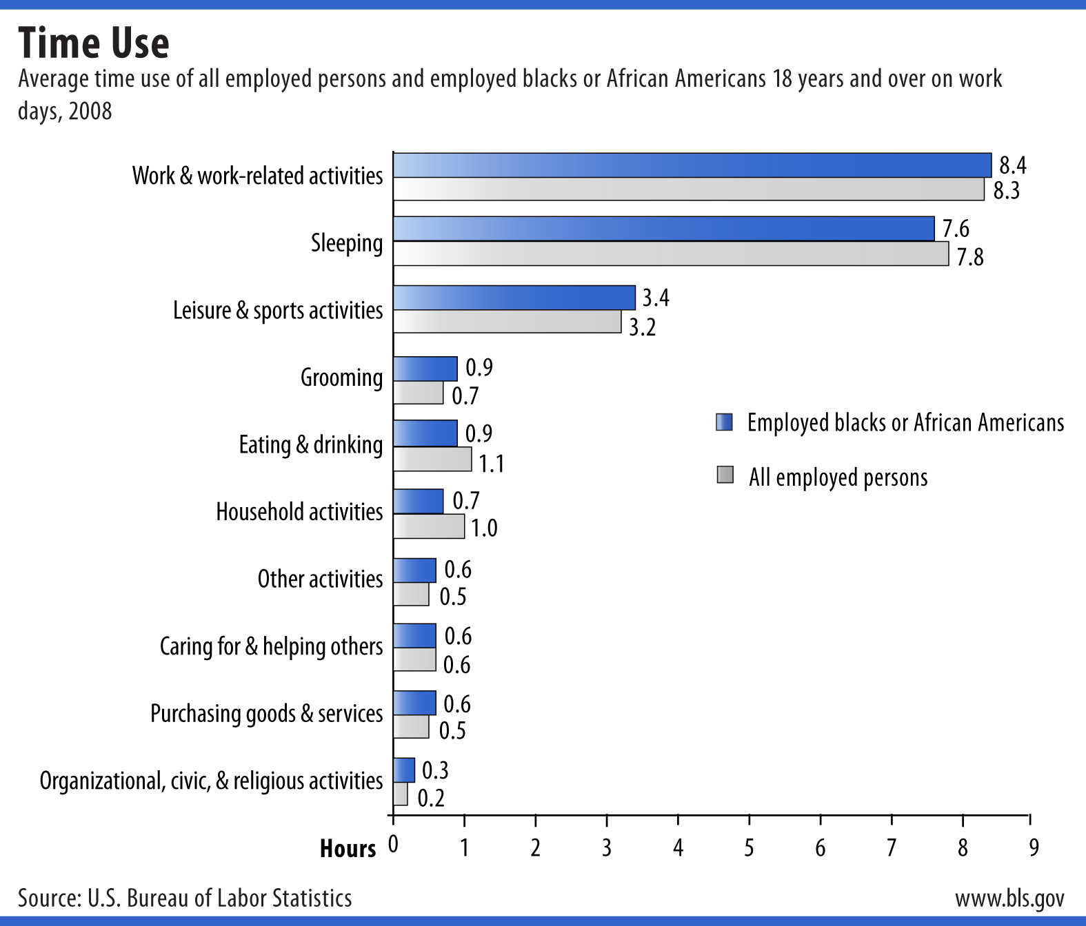
Source: American Time Use Survey

More Info

General Information
For more information, please call (202) 691-5200.

Media Contact
The news media can contact the BLS Press Officer at
(202) 691-5902.

Note: Data in text, charts and tables are the latest available at the time of publication. Internet links may lead to more recent data.

